**Synopsis of CSE326**

**Project Name**                   : Fitness Club  
**Language Used                   :**  HTML, CSS, JAVASCRIPT.  
**User Interface Design       :**  HTML,CSS,JAVASCRIPT  
**Web Browser                       :** Mozilla, Google Chrome, IE8, OPERA  
**Software use                         :** visual studio, notepad++,notepad.   
In this project we use HTML, JavaScript and CSS. It has two modules admin and user.

***Brief description of the modules*  
 #.** Name of the Gym is **Fitness club.**

**#** Then you insert various type of image which will moving like customers and and various type of gym kits.

**User can see the ----**   
**0. Home Page**: User can take admission in the fitness club trough the register form which will be provide in the register new portal.  
**0. Trainings**: User can choose their training which platform they want to work and they chose and their personal trainer if they want ,it is not a mandatory condition .  
**0. About Us**: User sees the details of Fitness club.

**0. Timetable:** User can booking their time table in online.

User can see admission fee—

* **Year wise- 23000/-**

**or**

* **Month wise-2000/-**

**User can see the discount on special moment .**

**0.Gallery:** user can see the our gallery where they see our club’s photos.

**0. Contact Us**: User can contact with beauty parlor.

**#.** User can also see fitness club facebook, Twtter, and Insta account. Link is given in the home pages

***Name of the group members:***

**1.Abhinav Adarsh (reg no. 11908522)**

**2.Ankit Tiwari (reg no. 11908404)**

***Work plan and gntt chart:***

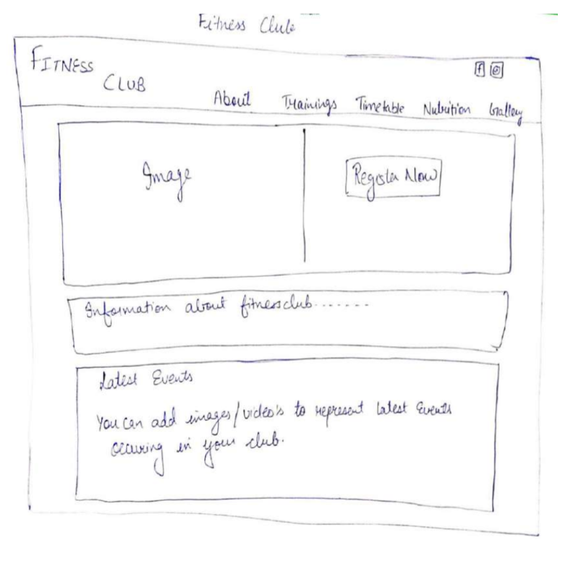

**Submitted to:** Manu Bali